Lab: Containers and Docker
Lab for the "Containers and Clouds" course @ SoftUni

NGINX Server Container
In this task, we will run a simple NGINX server in a Docker container. The server only returns some server information:
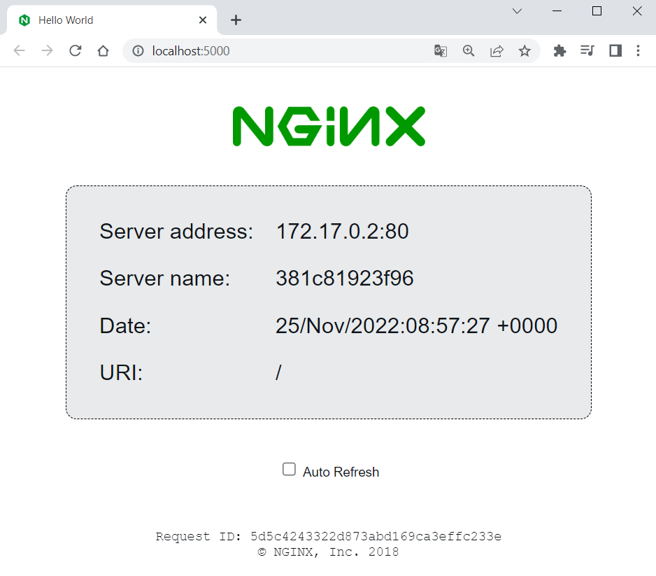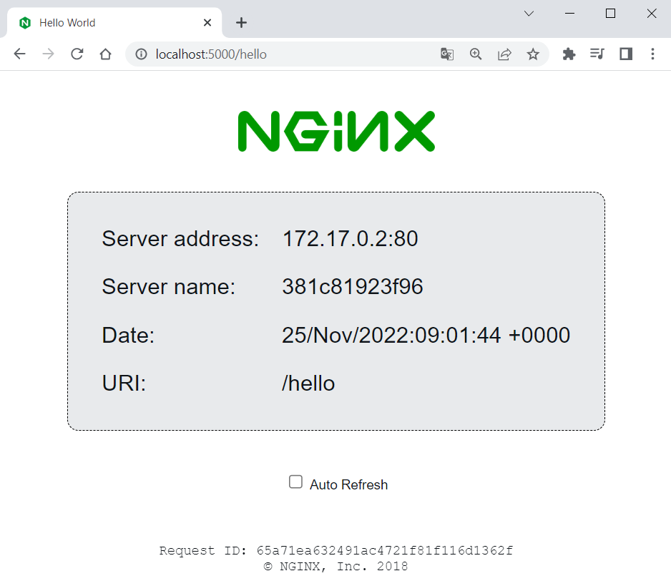

Download Image
To create a NGINX server container, we shall first pull the NGINX server image from Docker Hub. You can find the image documentation on Docker Hub here: https://hub.docker.com/r/nginxdemos/hello. You can always refer to the documentation to get instructions on how to pull, build and run the image:
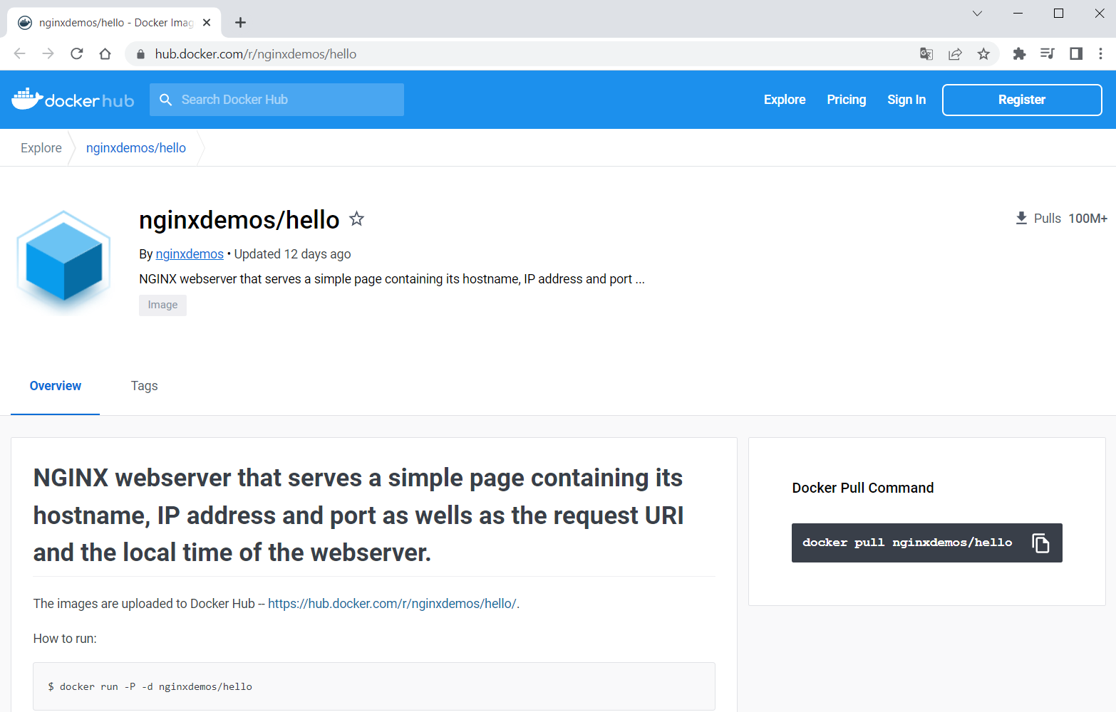
Open a CLI, for example, PowerShell or Windows Terminal or Command Prompt (PowerShell is recommended), and let's first pull the Docker image of the server. You should just use the pull command from the documentation:
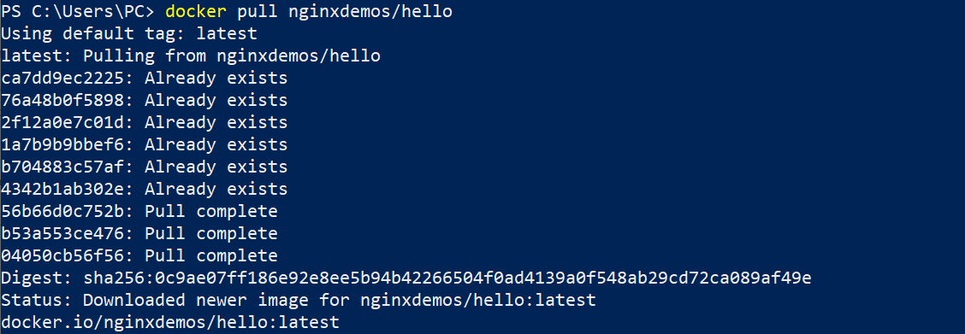
You can see that the latest image is downloaded by default. In addition, some of the image layers existed from before (from other installations), so they were not downloaded again – this is the advantage of Docker image layers.
You can look at your downloaded images in Docker Desktop, in the [Images] tab:
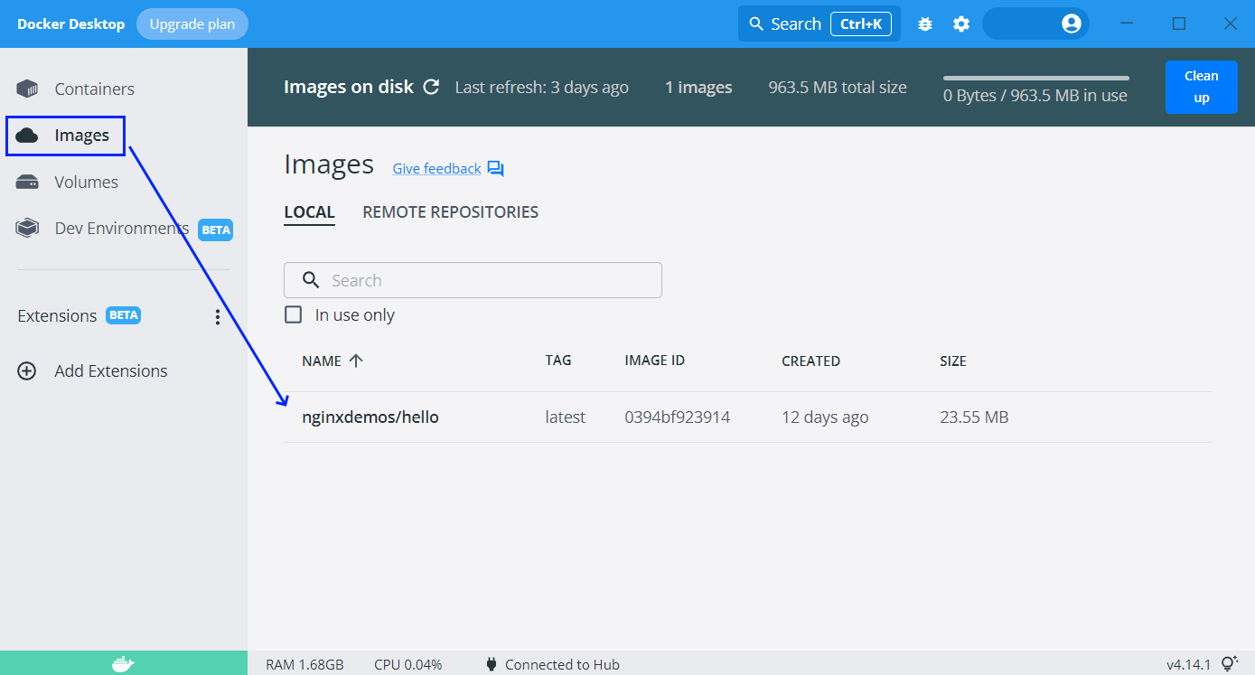
You can also use the command below to display a list of all images you have:

Run a Container
Now we want to run a container with the NGINX server image, which is already downloaded from Docker Hub to our local machine. Use the docker run command and try this way:
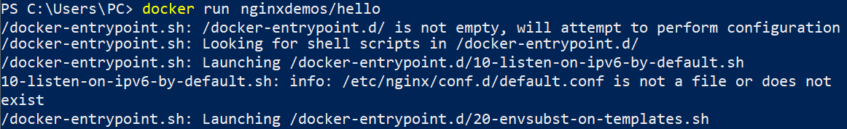
Now we have a running container with a random name, as we did not set it explicitly. We can see it in Docker Desktop, in the [Containers] tab:
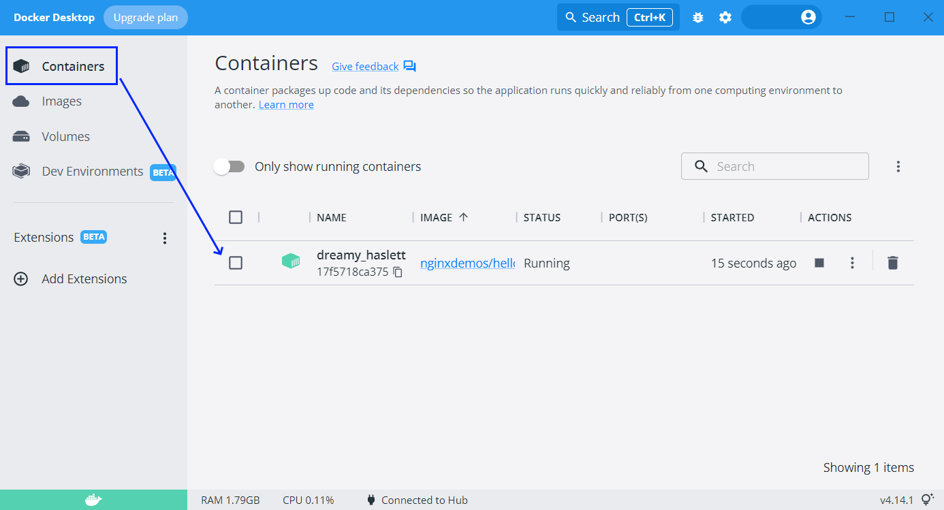
However, you can see that the "PORT(S)" column is empty, which means that our container cannot be accessed through the Internet, as it is isolated.
To fix this, we should expose a port from the container. But first, let's stop and delete the container, which we already have, by clicking on the buttons in Docker Desktop, as shown below:
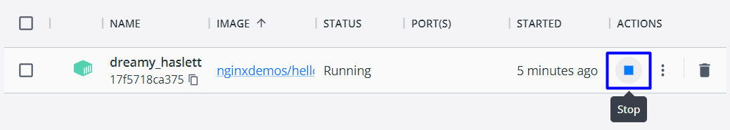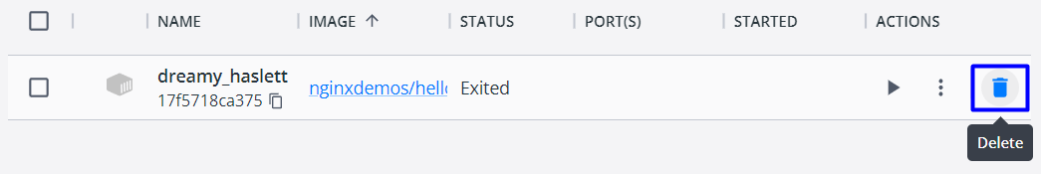
Let's create another container and publish its port to the host. This is done with the -p option. After it, we shall add the port we want the server to be on our machine (it can be any free port, but let's use 5000) and the internal port the server uses – in our case 80. Do it like this:
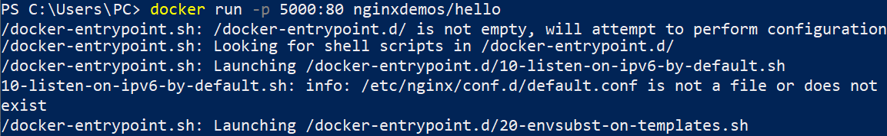
Now the container is exposed:
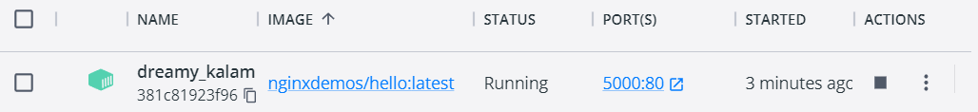
So, you can go to http://localhost:5000 and access the working server:
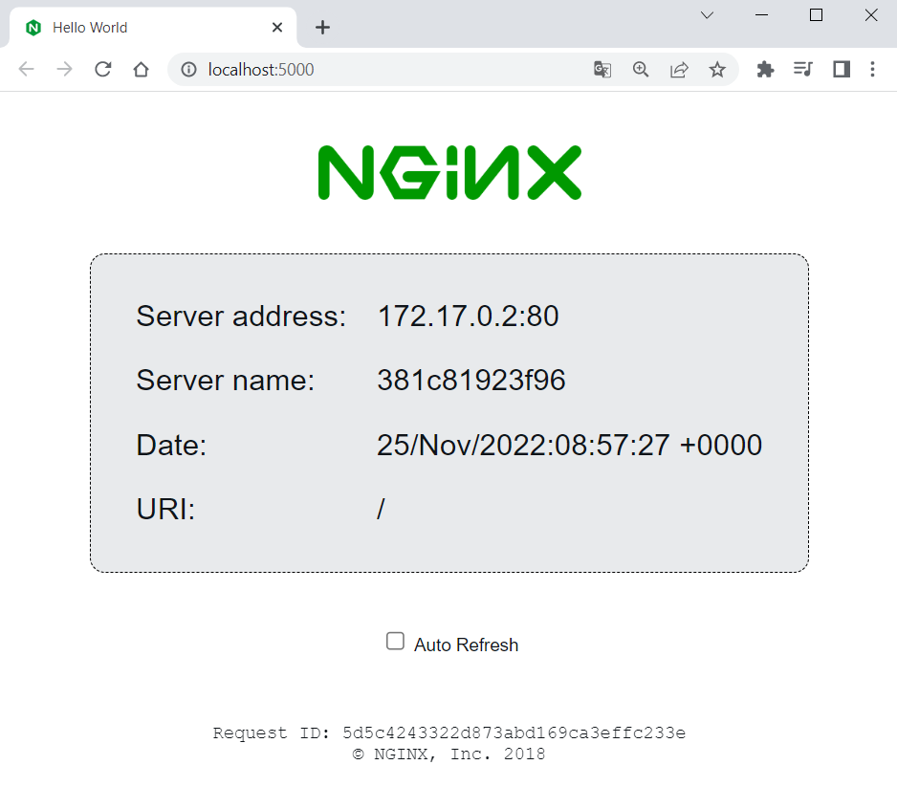
Stop and delete the container again and let's do one more thing.

Run a Named Container in Detached Mode
This time, we want to run a container with a name and in detached mode (the container will be running in the background). To do this, use the --name option with the container name you want, and the -d option for detached mode:
As you can see, now we have only the container id returned in the terminal and the container logs are now shown (because of the detached mode). However, you can see the logs with docker logs and the container id or name:
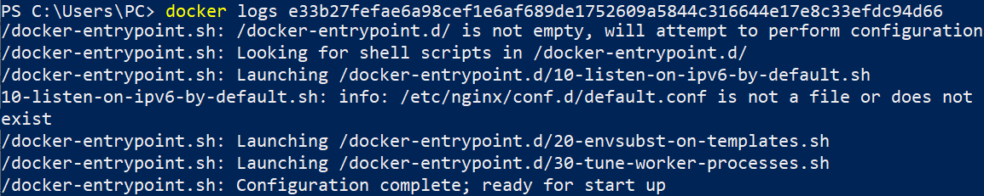
You can also use only the first two symbols of the container's id, not the whole one when they are unique (we have no other container with the same first symbols):
Or you can see them directly from Docker Desktop when you click on the container's name:
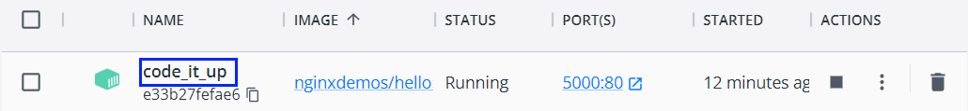
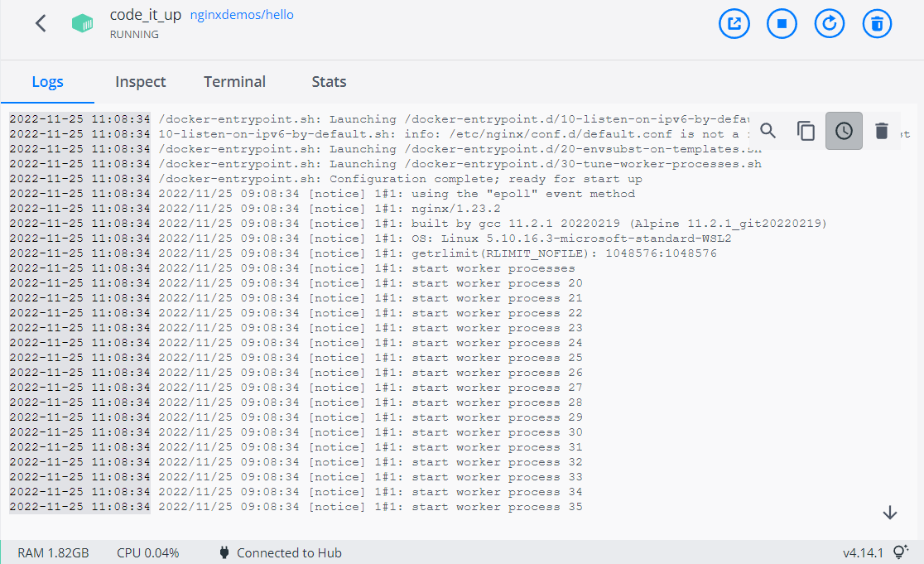
Notice that the name of our container is how we explicitly set it to be.

Examine and Delete Container and Image
We can see all containers we have like this:
To see all running containers, use:
In our case, we have a single running container and we have the same output from the two commands.
Now let's use the terminal to stop and delete our container. Use the following commands with the container id or container name:
Both commands return the id or the name of the container.
Finally, we can also delete the NGINX server image:
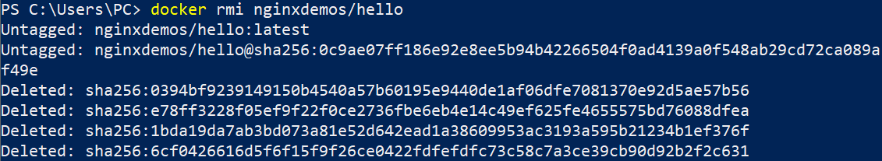
That's how we are supposed to work with Docker images and containers at a basic level.

Vue.js App in Container
Now we will see how to run a Vue.js app in a Docker container. We will create an app just for the demo.

Create and Set Up a Vue.js App
Let's use Terminal to create an app called MyWebsite, in a folder you choose:
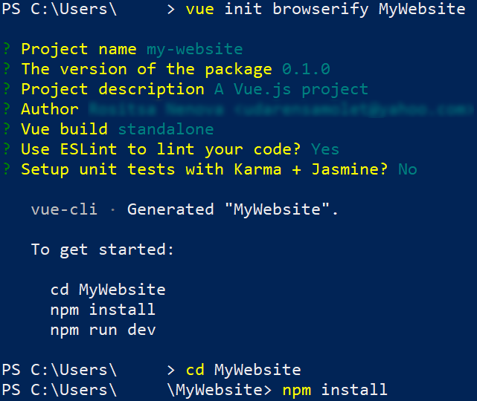
Let's now pull the image we will need to run the app – NodeJs.
(https://hub.docker.com/_/node). Note that the image version should be the same as the app's Node version:
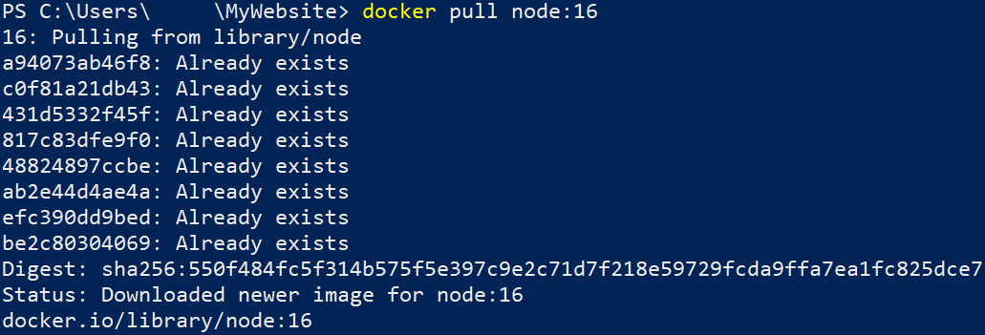
Now let's run the application locally in the standard way to check if everything works as expected:
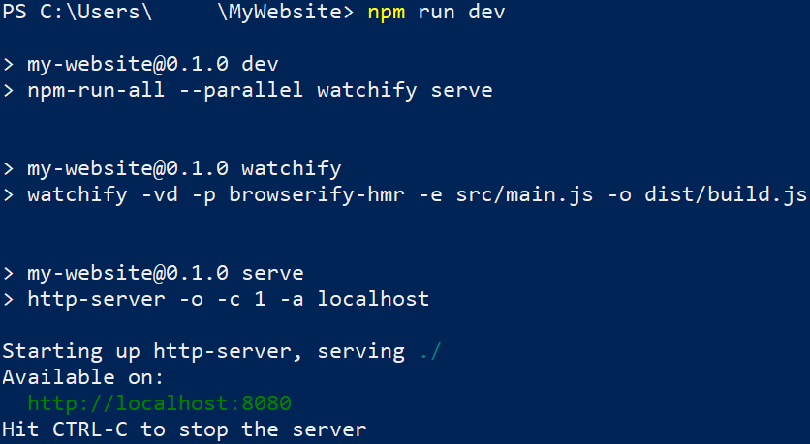
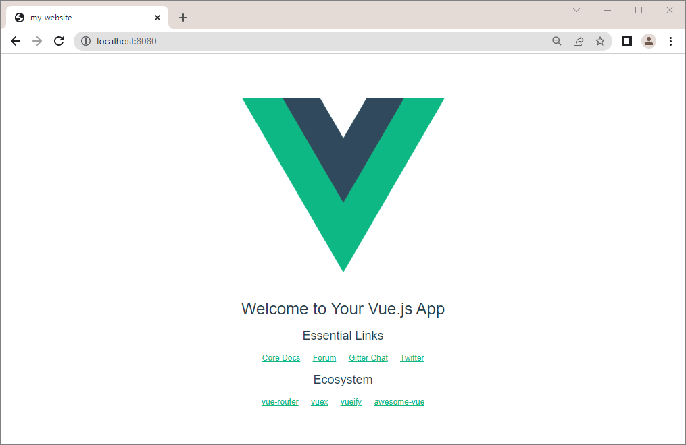
Now we should modify the app's package.json file, so that the app runs on the IP we want. Open the file in any editor and change the scripts section settings like this:
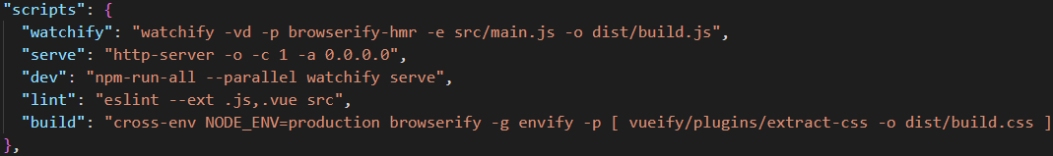

Run the App in a Container
To run the Vue.js app in a container, we will need to create a container with an exposed port, a volume and an interactive shell, so that we can run the app inside the container with the docker run command.
To do so, execute the following command:
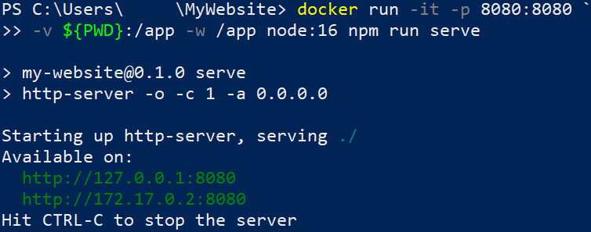
Access the app at http://127.0.0.1:8080 to validate that the app is running:
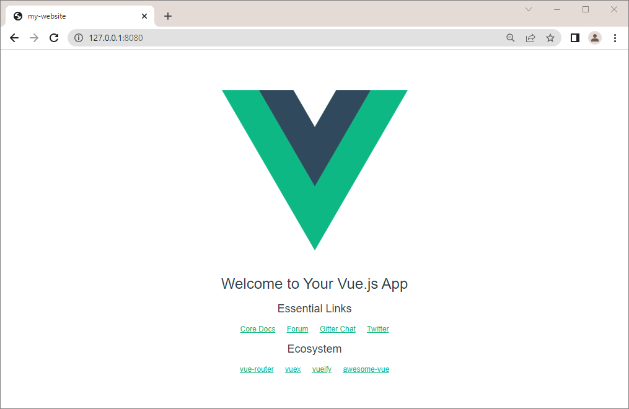

MongoDB in Container
Our next task is to run a container with a Mongo database in it. To do this, we will need the following image from Docker Hub: https://hub.docker.com/_/mongo
You can look at the "How to use this Image" section to learn how to run the database container. However, we will also show and explain the process step by step.

Create the Container
First, pull the latest MongoDB image with the docker pull mongo command:
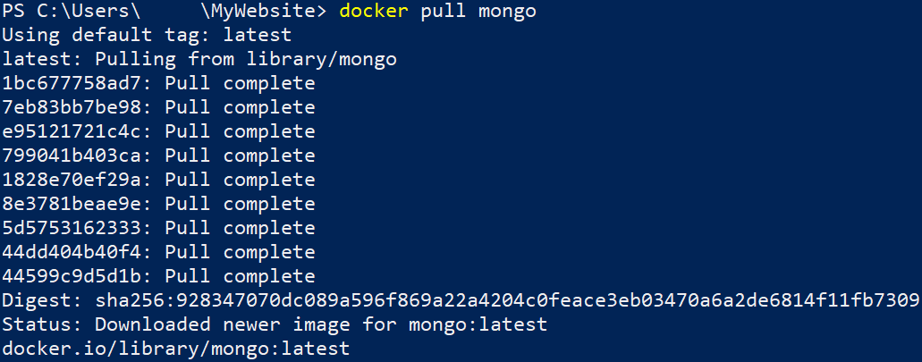
You can examine the documentation on how to use the image: https://hub.docker.com/_/mongo

Run a Database Container
Our next step is to run the container, using the following command:
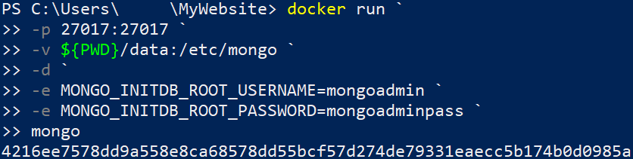
- docker run → starts a new Docker container;
- -p 27017:27017 → sets the external and internal ports to 27017, so that we can access the MongoDB from outside the container;
- -v ${PWD}/data:/etc/mongo
  - ${PWD} → the host directory;
  - /etc/mongo → the container directory;
- -d → runs the container in detached mode (it will run in the background);
- -e MONGO_INITDB_ROOT_USERNAME=mongoadmin → sets the admin username;
- -e MONGO_INITDB_ROOT_PASSWORD=mongoadminpass → sets the admin password;
- mongo → specifies the image.
You should disable host's MongoDB Server instances or use another port!
Admin password should always follow the rules from the documentation.
When MongoDB Server container is started, other apps can log in to it and use the database.
Run a Database Container with Volume
To persist data after container is stopped, create a volume, using the following command:
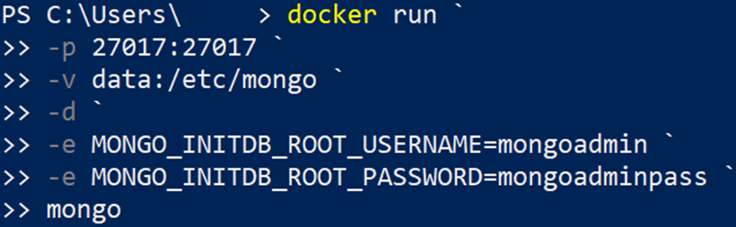
You can then easily backup or restore the data from the volume.

Connect to the Database Container through MongoDB Compass
You can connect to the container database in MongoDB Compass, using the username and password that we created in the previous step:
